**PIZZA SALES SQL QUERIES**

**Total Revenue:**

select sum(total_price) as Total_Revenue from pizza_sales;

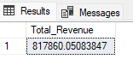

**Average Order Value:**

select sum(total_price)/count(distinct (order_id)) as

Average_Order_Value from pizza_sales;

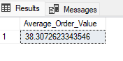

**Total Pizza Sold:**

select sum(quantity) as Total_Sold_Pizza from pizza_sales;

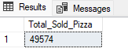

**Total Orders:**

select count(distinct(order_id)) as Total_Pizza_Orders from

pizza_sales;

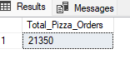

**Average Pizza Sold Per Order:**

SELECT CAST (CAST (SUM(quantity) AS DECIMAL (10,2)) /

CAST (COUNT (DISTINCT order_id) AS DECIMAL (10,2)) AS DECIMAL (10,2)) AS Avg_Pizzas_Per_order from pizza_sales;

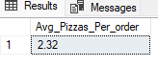

**Daily Trend for Total Orders:**

select DATENAME(DW,order_date) as Order_Day, count(distinct(order_id)) as Total_Orders

from pizza_sales

group by DATENAME(DW,order_date);

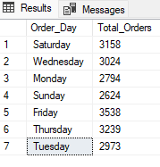

**Monthly Trend for Total Orders:**

select DATENAME(MONTH,order_date) as Month_Name, count(distinct(order_id)) as Total_Order

from pizza_sales

group by DATENAME(MONTH,order_date);

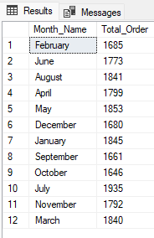

**Percentage of Sales by Pizza Category:**

SELECT pizza_category, sum(total_price) as Total_Sales,

sum(total_price) * 100 / (SELECT sum (total_price) from pizza_sales) as percent_Total_Sales

from pizza_sales

GROUP BY pizza_category;

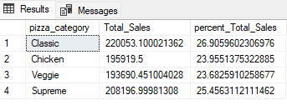

**Percentage of Sales by Pizza Size:**

total_price) from pizza_sales) as percent_Total_Sales

from pizza_sales SELECT pizza_size, sum(total_price) as Total_Sales, sum(total_price) * 100 / (SELECT sum (

GROUP BY pizza_size;

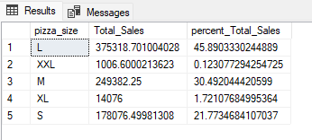

**Total Pizzas Sold by Pizza Category:**

SELECT pizza_size, sum(total_price) as Total_Sales, sum(total_price) * 100 / (SELECT sum (total_price)

from pizza_sales) as percent_Total_Sales

from pizza_sales

GROUP BY pizza_size;

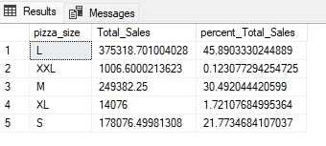

**Top 5 Best Sellers by Revenue:**

SELECT TOP 5 pizza_name, SUM (total_price) AS Total_Revenue FROM pizza_sales

GROUP BY pizza_name

ORDER BY Total_Revenue DESC;

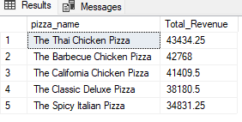

**Top 5 Best Sellers by Quantity:**

SELECT TOP 5 pizza_name, SUM (quantity) AS Total_Quantity FROM pizza_sales

GROUP BY pizza_name

ORDER BY Total_Quantity DESC;

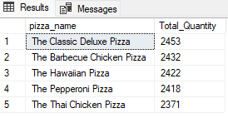

**Top 5 Best Sellers by Total Orders:**

SELECT TOP 5 pizza_name, COUNT(DISTINCT order_id) AS Total_Orders FROM pizza_sales

GROUP BY pizza_name

ORDER BY Total_Orders;

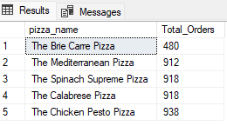

**NOTE**

**If you want to apply the Month, Quarter, Week filters to the above queries you**

**can use WHERE clause. Follow some of below examples**

SELECT DATENAME(DW, order_date) As order_day, COUNT (DISTINCT order_id) As

Total_orders

FROM pizza_sales

WHERE MONTH(order_date)= 1

GROUP BY DATENAME(DW, order_date)

**"Here MONTH(order_date) 1 indicates that the output is for the month of**

**January. MONTH(order_date) 4 indicates output for Month of April.**

SELECT DATENAME(DW, order_date) As order_day, COUNT (DISTINCT order_id) AS

total_orders

FROM pizza_sales

WHERE DATEPART(QUARTER, order_date)=1

GROUP BY DATENAME(DW, order_date)

**"Here DATEPART(QUARTER, order date) 1 indicates that the output is for**

**the Quarter 1. MONTH(order_date) 3 indicates output for Quarter 3.**